LAN and Wi-Fi Network System developed at BASU and its Colleges
A Network Centre / Data Centre have been established in the BASU to carry out all the computerized/ online activities of BASU. 50 Mbps NKN leased line for BASU and 20 Mbps leased line for COF were installed. Wi-Fi and Local Area Network have been created in all the colleges to help the students and faculties for teaching, research and extension activities. This LAN was developed by calling online Bid through Beltron on 16.02.2019. The tender document was developed with the help of IT expert of ICAR. The pre bid meeting was held on dated 27.02.2019. Total eleven IT Firms were participated in the pre bid meeting. The proceeding of Prebid meeting was uploaded in the BASU website and Beltron on 24.04.2019. The technical bid was opened on 25.05.2019, which was examined by the expert committee. IT Expert from NDRI, ICAR HQ, New Delhi and Director, NIT, Bihar was member of the committee. Financial Bid of technically qualified firms were opened on 6.07.2019. On the basis of Lowest rated the work was awarded to M/s Graphic Trades Pvt. Limited on 30.07.2019. The total cost of this LAN and developing Data Centre comes to Rs 14.92 Crore. This firm has completed the entire LAN and Wi-Fi Network Work (1000 internet node and 220 Wi-Fy access points) in all 29 different buildings in the BASU HQ, BVC, VCC, ILFC, Pultrary Farm, Hostels (Boys and Girls), New Academic Building, New Library Building, Liason Office, Gust House, SGIDT and COF Kishan Ganj. This Data centre was inaugurated by Honable AH&FR Minster Dr Prem Kumar Ji and Dr N. Sarvan Kumar, Secretary AH&FR on 10 June 2020.

This LAN will be more useful for effective implementation of Chanakya Academic Automation Software for which proper training was provided to all concerned faculty members of BASU for using this software/application. The enrolment of students, e-course offering, registration of the students in the semester and online fee payments, examination and publication of results etc. are conducted through Chanakya software. All faculties are using this software for day to day academic work. To improve the whole teaching learning process every classroom is fitted with modern tools like projector, and electronic podium for delivering lectures.

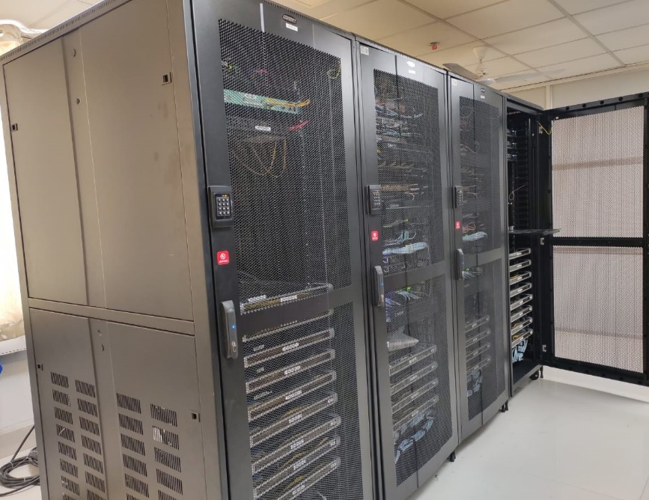
Hospital management system for managing different activities in Veterinary clinical complex have also implanted through local Area Network. University information have been made available on University Website. All information related to admission, Results, Recruitment, Tenders, course material, teaching lecture, PPTs, other study material, Notice, Circulars etc. have been made available on BASU website. E-content on different topics have also been uploaded for the benefit of student community. The details of books/documents at the College/ University Library have been entered in the KOHA Library Management software. This LMS is open Source Software and useful for the computerization of library activities and services in the networked environment. This software contains various modules such as Administration, Acquisition, Cataloguing, Circulation, Serial control, Article Indexing, Budget Control, OPAC (Online Public Access Catalogues) etc. Apart from this the digital form of dissertation submitted by students are available in the Krishi Kosh Institutional Repository of NARS. The connectivity of CeRA is also available in the library, and on BASU Local Area Network which is being used by the faculty members and students of college

Login password have been assigned to all Faculty members of BASU for using URKUND Anti Plagrisiam software provided by the UGC INFLIBNET and Faculty member of BASU are using this UGC Facility through our newly developed LAN. language Lab in three Colleges have been installed. 75 Computers have been installed and are connected with LAN CCTVs were installed in different locations i.e. Administrative Building, Finance Office, Bihar Veterinary College, Sanjay Gandhi institute of Dairy Technology and Vice-Chancellor residence office. Guest House, BASU Library. Biometric attendance System for Regular and Contractual Staff have been implemented and though this LAN University is monitoring all the attended system of manpower. E-Tendering system/ E-Procurement System have been implemented with the help of Beltron. Online Recruitment for the post of teaching staff at COF and BVC is going on and date of all applicants are available in the Registrar office and data centre. This Online Recruitment process will also continue for other recruitments of others Teaching and Non-teaching staff also. Financial Management System of NIC have also been implemented and most of the financial activities have been computerized. Implementation of E-office for managing other administrative activities in the University is under process.

.

