Fundamentals of Microbiology

Code – DE23

Name-Dr. Sonia Kumari

Asstt. Prof cum Jr. Scientist, Dairy Microbiology

SGIDT, Bihar Animal Science University, Jagdeopath

Patna, Bihar

Module-1

Lesson 2. Applications of Microbiology- Food, Industrial and Environment.
Objectives:
1. To know the application of microorganisms for the benefits of mankind.
2. To know the various Sources and Factors affecting spoilage of food.
Microorganisms have many applications in various fields. They can be applied to every field of science but here some of the important field has been discussed

2.1. Food Microbiology
Food microbiology encompasses the study of microorganisms which have both beneficial and deleterious effects on the quality and safety of foods. It focuses on the general biology of the microorganisms that are found in foods including: their growth characteristics, identification, and pathogenesis. Specifically, areas of interest which concern food microbiology are: food poisoning, food spoilage, and food legislation. Pathogens in product, or harmful microorganisms, result in major public health problems worldwide and are the leading causes of illnesses and death. In the United States alone, food borne illness has been estimated to cause 5,000 deaths and 76 million illnesses per year.

2.1.1. Factors affecting Microbial Growth in Food:
There are broadly two types of factors that affect the growth of microorganisms in food products:
- Intrinsic: The intrinsic parameters are properties that exist as part of the food product itself such as pH, moisture content (water activity), Oxidation-reduction potential, nutrient content, antimicrobial constituents and biological structures of food.
- Extrinsic. On the other hand, extrinsic parameters are those properties of the environment (processing and storage) that exist outside of the food product and, may affect both the foods and their microorganisms. These include storage temperature of food, relative humidity, presence/concentration of gases and presence/activities of other microorganisms.

2.1.2. Sources of Microorganisms in Food

Microorganisms can be found virtually everywhere including humans and can enter food products through different routes. Some of the most common ways in which microorganisms enter food products are as follows: Soil, Water, Air, Food Handlers, Utensils, Vegetables (plant) and vegetable products, Globalization of food supply and Terrorist attacks

2.1.3 Food borne Illness
Microorganisms can cause a variety of effects in food products including spoilage, which primarily affects product quality, and food poisoning, which is generally caused by pathogens. Term food borne illness or disease indicates - a disease or illness caused by the consumption of contaminated foods or beverages.
Food borne diseases are primarily of two types:
- Food-borne infections: This is caused due to ingestion of microbes, followed by growth, tissue invasion, and/or release of toxins,
- Food Intoxications. Caused as a result of ingestion of toxins in foods in which microbes have grown. More than 250 different food borne diseases have been described. Most of these diseases are infectious, caused by a variety of bacteria, viruses, and parasites.
- Food Toxiinfection: Caused by harmful toxins or chemicals that have contaminated the food, for example, poisonous mushrooms or heavy metal contamination.

2.1.4. Food Spoilage
Spoilage organisms alter food which results in changes in texture, appearance and organoleptic qualities of the food, making it unsuitable for human consumption. Spoilage is often the result of a succession. One organism creates an environment conducive to the growth of another.
Common microbial food spoilage is:

- Putrefaction- Protein + Proteolytic microorganism’s — amino acids + amines + ammonia + H2S.
- Fermentation- Carbohydrates + Fermenting microorganism’s —acids + alcohols + gases
- Rancidity- Fatty foods + Lipolytic microorganism’s — Fatty acids + Glycerol
2.2. Food Preservation
It is the process of treating and handling food to stop or greatly slow down spoilage (loss of quality, edibility or nutritive value) caused or accelerated by microorganisms. Some methods, however, use benign bacteria, yeasts or fungi to add specific qualities and to preserve food (e.g., cheese, wine). Maintaining or creating nutritional value, texture and flavor is important in preserving its value as food. Preservation usually prevents the growth of bacteria, fungi, and other microorganisms, as well as retarding the oxidation of fats which cause rancidity. It also includes processes to inhibit natural ageing and discoloration that can occur during food preparation such as the enzymatic browning reaction in apples after they are cut. Some preservation methods require the food to be sealed after treatment to prevent recontamination with microbes; others, such as drying, allow food to be stored without any special containment for long periods.
Common methods of applying these processes include drying, spray drying, freeze drying, freezing, vacuum packing, canning, preserving in syrup, sugar crystallization, food irradiation, and adding preservatives or inert gases such as carbon dioxide. Other methods that not only help to preserve food, but also add flavor, include pickling, salting, smoking, preserving in syrup or alcohol, sugar crystallization and curing.

2.2.1. Fermented Foods
It is one of the most common method of food preservation is fermentation process. These are the foods that have been subjected to the action of micro-organisms or enzymes, in order to bring about a desirable change. Numerous food products owe their production and characteristics to the fermentative activities of microorganisms. Fermented foods originated many thousands of years ago when presumably microorganism contaminated local foods. Fermentation is most common method of preservation. Furthermore, microbial fermentation can increase nutritional quality and digestibility of food while producing desirable textures and flavors (organoleptic properties). Fermentation, like spoilage, is dependent on microbial succession. The physical and chemical nature of the food determines fermentation organisms and inhibits unwanted microbes. Microbes involved are lactobacilli (lactic acid bacteria), acetic acid bacteria, yeasts and occasionally mycelial fungi. Early procedures used ‘backslop’ method. They retained some material from a previous fermentation and added it to a fresh batch of ingredients. Today, “starter cultures (collection of well identified and characterized microorganisms which initiate fermentation) are extensively used in the dairy industry. Some examples of fermented foods are as follows:
- Dairy Products- Buttermilk, Sour cream, Yoghurt, Cheese
- Meat Products: Many European sausages, Cured ham, Salami
- Fish products: Mainly Far East.
- Vegetables and Cereal Fermentation Products.
- Wine, Bread, Sourdough, Tofu, Pickles, Silages

2.3. Industrial Microbiology
Humans use the versatility of microbes to make improvements in industrial production, agriculture, medicine, and environmental protection. Use of microorganisms, usually grown on a large scale, to obtain valuable commercial products by way of significant chemical transformations is called industrial microbiology.
This discipline of microbiology dates back and originated with beer and wine making fermentation processes (alcoholic fermentation) and subsequently expanded in the area of production of pharmaceuticals (e.g. antibiotics), food additives (e.g. amino acids), organic acids (e.g. butyric acid and citric acid), enzymes (e.g. amylases, proteases), and vitamins. All these products are obtained by enhancing the metabolic reactions that microorganisms were already capable of carrying out in natural conditions. But, at present, in addition to this traditional industrial microbiology, a new era of microbial biotechnology is rapidly expanding in which the genes of the microorganisms responsible for such and other metabolic reactions are being manipulated to give to many new products at commercial level.

2.3.1. Fermentation in Industry: Fermentation is one of the main processes used in industrial microbiology. Fermentation is any process involving the mass culture of microorganisms, either anaerobic or aerobic. This process requires control of a series of parameters that depend on the desired final product. Throughout time, strain selection, culture media improvement, and preservation techniques have contributed to optimize the fermentation process in industry.
In industry, as well as other areas, the uses of fermentation progressed rapidly after Pasteur's discoveries. Between 1900 and 1930, ethyl alcohol and butyl alcohol were the most important industrial fermentations in the world. But by the 1960s, chemical synthesis of alcohols and other solvents were less expensive and interest in fermentations waned. Interest in microbial fermentations is experiencing a renaissance. Plant starch, cellulose from agricultural waste, and whey from cheese manufacture are abundant and renewable sources of fermentable carbohydrates. Additionally, these materials, not utilized, represent solid waste that must be buried in dump or treated with waste water (Fig. 2.1).
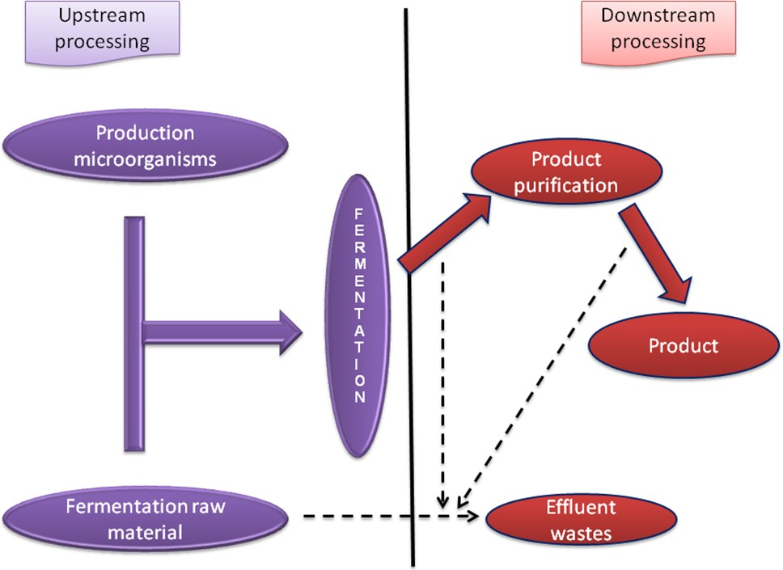

Fig. 2.1 Industrial microbiology

2.3.2. Major products of industrial microbiology: The major products of industrial microbiology can be enlisted as follows:
- Food and beverage biotechnology - fermented foods, alcoholic beverages (beer, wine) and flavors.
- Enzyme technology - production and application of enzymes.
- Metabolites from microorganisms - amino acids, antibiotics, vaccines, biopharmaceuticals, bacterial polysaccharides and polyesters, specialty chemicals for organic synthesis (chiral synthons).
- Biological fuel generation - ethanol or methane from biomass, single cell protein, production of biomass, microbial recovery of petroleum.
- Environmental biotechnology - water and wastewater treatment, composting (and land filling) of solid waste, biodegradation/bioremediation of toxic chemicals and hazardous waste.
- Agricultural biotechnology - Soil fertility, microbial insecticides, plant cloning technologies, Diagnostic tools - testing & diagnosis for clinical, food, environmental, agricultural applications, biosensors

2.4. Environmental Microbiology
Environmental microbiology is the study of the composition and physiology of microbial communities in the environment. The environment in this case means the soil, water, air and sediments covering the planet and can also include the animals and plants that inhabit these areas. Environmental microbiology also includes the study of microorganisms that exist in artificial environments such as bioreactors. Microbial life is amazingly diverse and microorganisms literally covers the planet. It is estimated that we know less than 1% of the microbial species on Earth. Microorganisms can survive in some of the most extreme environments on the planet and some can survive high temperatures, often above 100°C, as found in geysers, black smokers, and oil wells. Some are found in very cold habitats and others in highly salt / saline, acidic, or alkaline water.

Microbial life is amazingly diverse and microorganisms literally cover the planet. An average gram of soil contains approximately one billion microbes representing probably several thousand species. Microorganisms have special impact on the whole biosphere. They are the backbone of ecosystems of the zones where light cannot approach. In such zones, chemosynthetic bacteria are present which provide energy and carbon to the other organisms there. Some microbes are decomposers which have ability to recycle the nutrients. Microbes have a special role in biogeochemical cycles. Microbes, especially bacteria, are of great importance because their symbiotic relationship (either positive or negative) have special effects on the ecosystem.

2.5. Soil Microbiology
Soil is the top layer of the Earth's lithosphere, formed from weathered rock that has been transformed by living organisms. Soil is composed of mineral and organic solid particles, air, soil solution, and living organisms which occur in this edaphon. The organisms living in soil create a community called the edaphon. These are bacteria, fungi, unicellular algae, vascular plants and animals especially invertebrates that occur in the surface layer of soil. Due to the variety of their metabolic abilities the soil microorganisms ensure the permanence (continuity) of element cycles in nature. The effect of their activities is not only the mineralization of organic compounds but also the changes of mineral compounds, which have a big impact upon the development of the green plants. Edaphon constitutes about 1-10% of the dry mass of the soil organic matter. Both bacteria and fungi are the co-creators of soil's structure as they create humus - the most important component of soil that greatly influences its structure, sorption qualities and the richness in organic compounds. They have a great effect on the way of creation of crumb texture and a spongy structure of soil by producing mucous capsules, and like the filamentous bacteria and the fungi by their form of growth.

2.6. Water Microbiology
The biotopes of water microorganisms may be underground and/ or surface waters as well as bottom sediments. The underground waters (mineral and thermal springs, ground waters) - due to their oligotrophic character (nutrient - deficient) are usually inhabited by a sparse microflora that is represented by a low number of species with almost a complete lack of higher plants or animals. The surface waters such as streams, rivers, lakes and sea waters are inhabited by a diverse flora and fauna. Microorganisms in those waters are a largely varied group. Next to the typical water species, other microorganisms from soil habitats and sewage derived from living and industrial pollution occur. Bottom sediments are a transient type of habitat i.e. the soil-water habitat that is almost always typically oxygen-free in which the processes of anaerobic decomposition by microorganisms cause the release of hydrogen sulphide and methane into water. In the bottom sediment, anaerobic putrefying microflora, cellulolytic bacteria and the anaerobic chemoautotrophs develop.
Microorganisms occupy surface waters in all of the zones; they may be suspended in water (plankton), cover stationary underwater objects, plants etc (periphyton), or live in bottom sediments (benthos). Plankton can be defined as the group of organisms that passively float in water not being able to resist the movement and the flow of water mass is called plankton or bioseston.

2.7. Air Microbiology: Air is an unfavorable environment for microorganisms, in which they cannot grow or divide. It is merely a place which they temporarily occupy and use for movement. Therefore, there are no metabolic connections occurring between different microorganisms in air (such as in soil or water). As a result, they form only a random collection of microorganisms. Microorganisms get into air as a consequence of wind movement, which sweeps them away from various habitats and surroundings (soil, water, waste, plant surfaces, animals, and other), or are introduced during the processes of sneezing, coughing, or sewage aeration. Air conditions are unfavorable for the microorganisms due to a lack of adequate nutrients, frequent deficit of water, threat of desiccation, and solar radiation. There are 3 main groups of microorganisms that occur in air: viruses, bacteria and fungi. Bacteria may exist as vegetative or resting forms, however fungi occur in the form of spores or fragments of mycelium.
Microorganisms in air occur in a form of colloidal system or the so-called bioaerosol. Every colloid is a system where, inside its dispersion medium, particles of dispersed phase occur, whose size is halfway between molecules and particles visible with the naked eye. In case of biological aerosols, it's the air (or other gases) that has the function of the dispersion medium, whereas microorganisms are its dispersed phase. However, it is quite rare to have microbes independently occurring in air. Usually, they are bound with dust particles or liquid droplets (water, saliva etc.), thus the particles of the bioaerosol often exceed microorganisms in size and may occur in two phases: dust phase (e.g. bacterial dust) or droplet phase (e.g. formed as the result of water-vapors condensation or during sneezing). The concentration of bioaerosol is dependent on the following factors:
- Number of emitted microorganisms, depending on the emitter.
- Distance from the source of emission.
- Wind speed.
- Microorganisms survival rate.
- Precipitation.
xxxxxxxxxxxxxxxxxxxxxxxxxxxxxxxxxxxxxxxxxxxxxxxxxxxxxxxxxxxxxxxxxxxxxxxxxxxxxx

