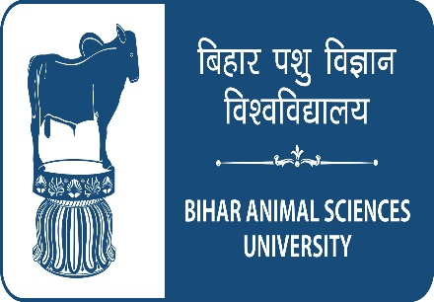 | fcgkj Ik'kq foKku fo'ofo|ky;
BIHAR ANIMAL SCIENCES UNIVERSITY
Patna- 800014
(Established in 2016 under Bihar Animal Science University Act-2016)

PROFORMA
NOTE:- | Please read the General Instructions & Conditions enclosed with application form before filling the application form.
Please Affix self-attested latest photograph
PLEASE INSERT INFORMATION IN BOLD LETTERS
Post Applied for | : | ……………………………………………
Dated | : | ……………………………………………

1 | Name  (In capital letters) |  | : | First Name |  |  | Middle Name | Surname
2 | Father’s / Husband Name |  | :
3 | Present Address (for correspondence) |  |  |  | :
4 | Permanent Home Address |  |  |  | :
5 | Telephone / Mobile No. |  |  |  | :
6 | Email |  |  |  | :
7 | Fax No. |  |  |  | :
8 | Date of Birth in figures and words  (According to Matriculation Certificate) |  |  |  | :
9 | Age as on last date of submission of application |  |  |  | :
10 | Have you ever been convicted by law for any offence? |  |  |  | :
11 | Have you ever been punished/dismissed/debarred from any govt. department/public sector organisation/quasi-govt organisation/university? |  |  |  | :
12 | Nationality |  |  |  | :
13 | a. | Mother Tongue |  |  | :
 | b. | Other language (s) which the applicant can speak, read and write fluently |  |  | :
14 | Whether belong to SC/ST/EBC/ BC/EWS/WBC Category (Candidates of original resident of Bihar, in support please enclose a certificate from authorized issuing officers) |  |  |  | :

Qualifications and experience

Examination* |  | Name of the degree / diploma | Name of the University or other examination body | Percentage of marks / OGPA obtained | Division | Year of passing | Subject (s) (Major)
i. | Matriculation
ii. | Higher Secondary / Intermediate / Pre-University
iii. | Bachelor’s Degree
iv. | Master’s Degree
v | Others

*Only completed and awarded qualifications will be considered. Incomplete or result awaited qualifications will not be considered. Attested copies of testimonials should be provided
*Candidate have to bring their original certificate/marksheet at the time of walk-in interview for verification purpose
*Candidate should bring character certificate issued by last attended institute/municipal body

15 | Experience: Teaching, Research, Extension, Field work or any other (Please describe each of the experience separately and in detail with its duration and dates)  ………………………………………………………………………………………………………………………………..  ………………………………………………………………………………………………………………………………………………………………………………………………………………………………………………………………
18 | Additional remarks, if any  ………………………………………………………………………………………………………………………………..  ……………………………………………………………………………………………………………………………………………………………………………………………………………………………………………………………….

NOTE: | All the statement should be supported by proof enclosure wherever necessary. If the space is insufficient additional sheet may be used where ever required.
DECLARATION
I ……………………………Son/Daughter of ……………………..hereby declare that all the statements and entries made in this application are true, complete and correct to the best of my knowledge and belief. In the event of any information being found false or incorrect or ineligibility being detected before or even after the selection my candidature/ appointment may stand cancelled.

Signature of the Applicant
Name (in block letters)

Date:- (Application not signed by the candidate is liable to be rejected.)

